*Florida International University*

*School of Computing and Information Sciences*

Software Engineering Focus

Feature Document

User Story ID <819>

**Name: Mairim Barrios**

**Team Member(s): Mairim Barrios, Carlos Martinez, Fidel Hernandez, Arelys Alvarez, Samira Tellez**

**Project: AR-VR-VE For COmputer Science**

**Product Owner(s)**: Dr. Francisco Ortega

**Mentor(s)**: Dr. Francisco Ortega

**Instructor**: Masoud Sadjadi

**User Story Name: Testing user interface**

* Description: **As a** User **I would like** to have a smooth experience while playing the game **so that** I can fully enjoy it.

Acceptance Criteria

* All test cases pass.
* Fix any bugs.

**Adding and removing commands**

* Name: Adding and removing commands
* Actor: the player
* Preconditions: is playing the game
* Description <The player does not encounter any bugs while playing the game>:

**Use Case Diagram**

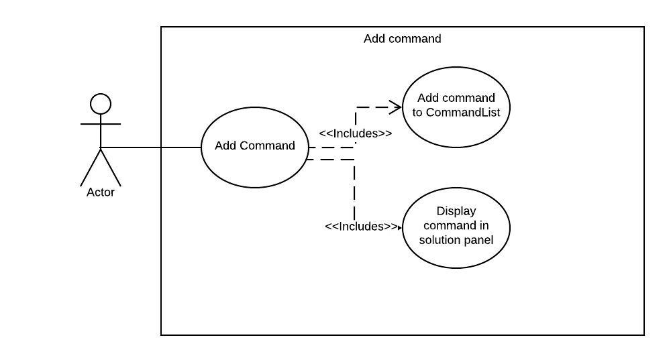

**Sequence Diagram**

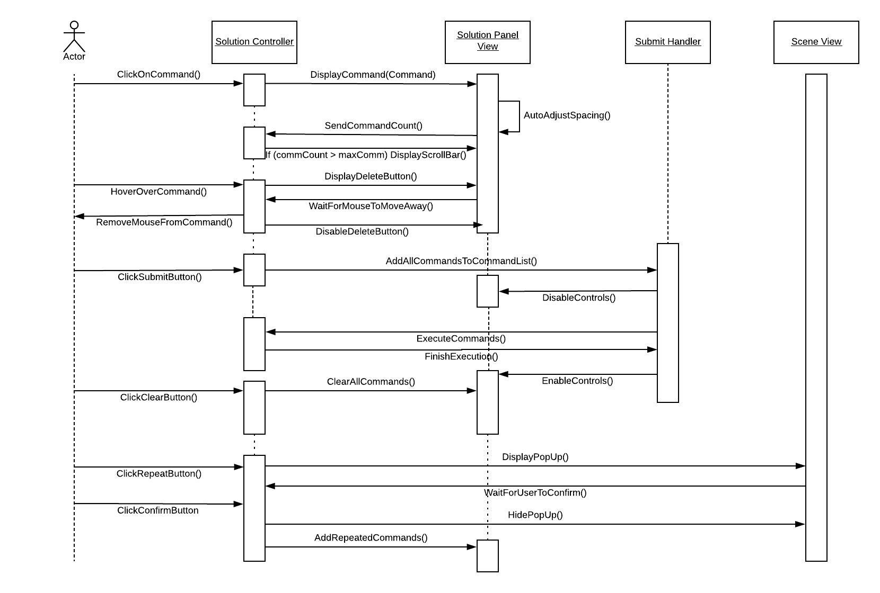

**Class Diagram**

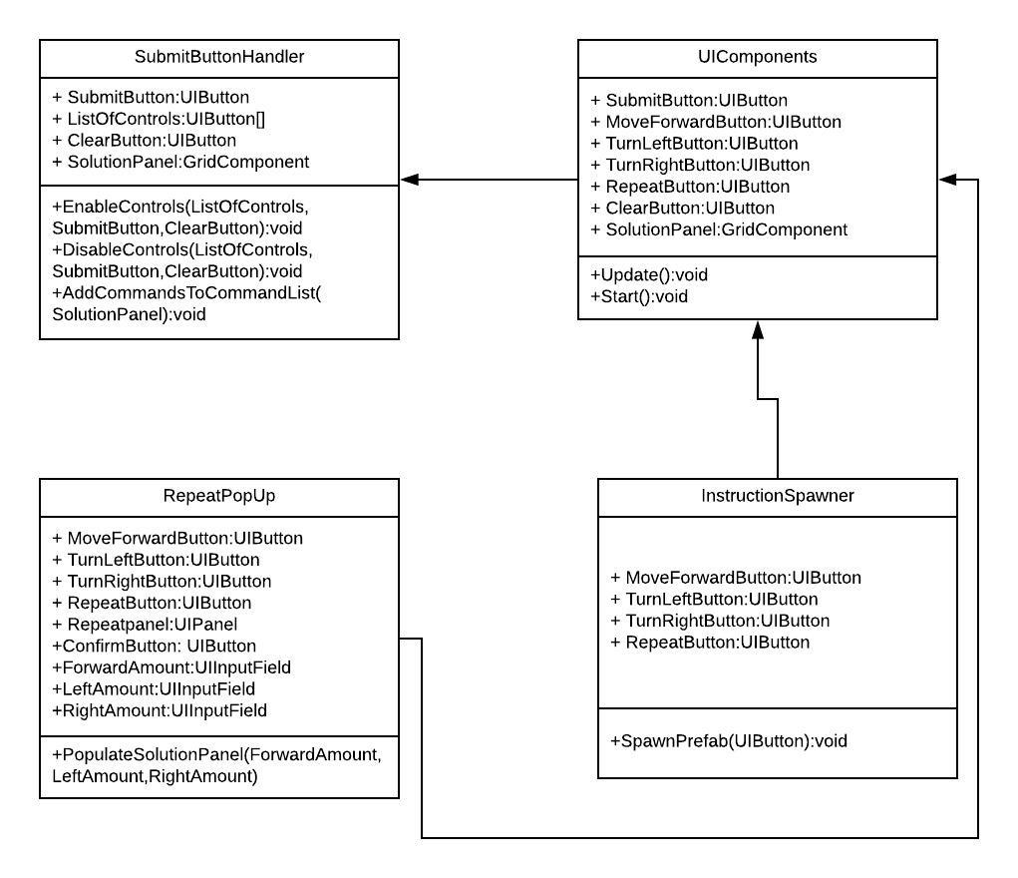

**Unit Test**

* Test case ID: 1
* Description/Summary of Test: Verify that by clicking a command control, the correct command pops up in the solution panel.
* Pre-condition: User clicks a command.
* Expected Results: Solution panel shows the same command being added.
* Actual Result: Status (Fail/Pass): Passed

**Unit Test**

* Test case ID: 2
* Description/Summary of Test: Verify that the delete button shows up when hovering over a command.
* Pre-condition: Player hovers over a command.
* Expected Results: Delete button shows up
* Actual Result: Status (Fail/Pass): Passed

**Unit Test**

* Test case ID: 3
* Description/Summary of Test: Verify that the delete button leaves when hovering away from a command.
* Pre-condition: Player’s mouse is currently over a command.
* Expected Results: The delete button leaves.
* Actual Result: Status (Fail/Pass): Passed

**Unit Test**

* Test case ID: 4
* Description/Summary of Test: Verify that all commands are deleted upon clicking the trash icon.
* Pre-condition: There are commands in the solution panel.
* Expected Results: All commands are deleted from the solution panel.
* Actual Result: Status (Fail/Pass): Passed

**Unit Test**

* Test case ID: 5
* Description/Summary of Test: Verify that the commandList on the backend is cleared when the trash icon is cleared.
* Pre-condition: The trash icon has been clicked.
* Expected Results: The commandList holding the commands deletes all of its items.
* Actual Result: Status (Fail/Pass): Passed

**Unit Test**

* Test case ID: 6
* Description/Summary of Test: Verify that the timer is paused when the game starts until the tool tips are finished.
* Pre-condition: The player has started playing.
* Expected Results: The timer begins after the last tool tip.
* Actual Result: Status (Fail/Pass): Passed

**Unit Test**

* Test case ID: 7
* Description/Summary of Test: Verify that the commands are added to the commandList on the backend when the user clicks on Submit.
* Pre-condition: There are commands in the commandPanel.
* Expected Results: The commandList gets populated when the player clicks on submit button.
* Actual Result: Status (Fail/Pass): Passed

**Unit Test**

* Test case ID: 8
* Description/Summary of Test: Verfiy that a panel with the repeat options pops up upon clicking the repeat button.
* Pre-condition: Player clicks on repeat button.
* Expected Results: A pop up panel shows up showing the optional commands and an input field to specify the amount of times it can be repeated and the order.
* Actual Result: Status (Fail/Pass): Passed

**Unit Test**

* Test case ID: 9
* Description/Summary of Test: Verify that after clicking the confirm button on the repeat panel, the solution panel is filled accordingly.
* Pre-condition: Player clicks the confirm button on the repeat panel.
* Expected Results: Solution panel gets populated
* Actual Result: Status (Fail/Pass): Passed

**Visual User Guide**

